**26. Remove Duplicates from Sorted Array**

Given an integer array nums sorted in **non-decreasing order**, remove the duplicates [**in-place**](https://en.wikipedia.org/wiki/In-place_algorithm) such that each unique element appears only **once**. The **relative order** of the elements should be kept the **same**.

Since it is impossible to change the length of the array in some languages, you must instead have the result be placed in the **first part** of the array nums. More formally, if there are k elements after removing the duplicates, then the first k elements of nums should hold the final result. It does not matter what you leave beyond the first k elements.

Return k*after placing the final result in the first*k*slots of*nums.

Do **not** allocate extra space for another array. You must do this by **modifying the input array**[**in-place**](https://en.wikipedia.org/wiki/In-place_algorithm) with O(1) extra memory.

**Custom Judge:**

The judge will test your solution with the following code:

int[] nums = [...]; // Input array

int[] expectedNums = [...]; // The expected answer with correct length

int k = removeDuplicates(nums); // Calls your implementation

assert k == expectedNums.length;

for (int i = 0; i < k; i++) {

assert nums[i] == expectedNums[i];

}

If all assertions pass, then your solution will be **accepted**.

**Example 1:**

**Input:** nums = [1,1,2]

**Output:** 2, nums = [1,2,_]

**Explanation:** Your function should return k = 2, with the first two elements of nums being 1 and 2 respectively.

It does not matter what you leave beyond the returned k (hence they are underscores).

**Example 2:**

**Input:** nums = [0,0,1,1,1,2,2,3,3,4]

**Output:** 5, nums = [0,1,2,3,4,_,_,_,_,_]

**Explanation:** Your function should return k = 5, with the first five elements of nums being 0, 1, 2, 3, and 4 respectively.

It does not matter what you leave beyond the returned k (hence they are underscores).

**Constraints:**

* 0 <= nums.length <= 3 * 104
* -100 <= nums[i] <= 100
* nums is sorted in **non-decreasing** order.

Hide Hint 1

In this problem, the key point to focus on is the input array being sorted. As far as duplicate elements are concerned, what is their positioning in the array when the given array is sorted? Look at the image above for the answer. If we know the position of one of the elements, do we also know the positioning of all the duplicate elements?  
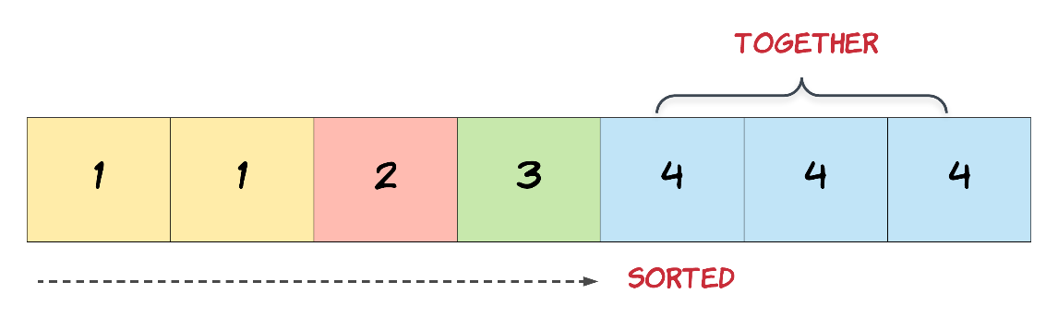

Hide Hint 2

We need to modify the array in-place and the size of the final array would potentially be smaller than the size of the input array. So, we ought to use a two-pointer approach here. One, that would keep track of the current element in the original array and another one for just the unique elements.

Hide Hint 3

Essentially, once an element is encountered, you simply need to **bypass** its duplicates and move on to the next unique element.